

**National Nuclear Security Administration**

**Annual MSI Technical Meeting**

**November 9 – November 10, 2010**

**Norfolk State University**

**700 Park Avenue**

**Norfolk, Virginia 23504**

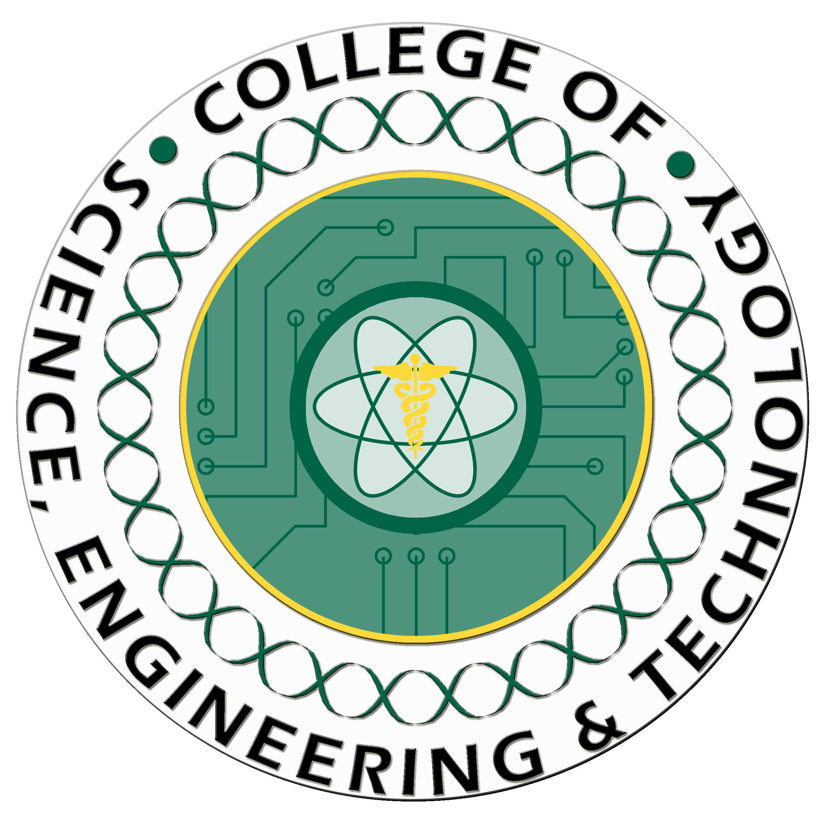

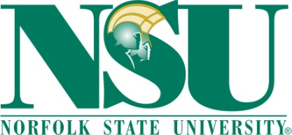

Message from the Conference Committee

Dear Participants:

It gives us a great deal of pleasure to welcome you to Virginia Beach, Virginia and thank you for attending the 2010 Annual MSI Technical Conference. Norfolk State University and Old Dominion University are honored to serve as co-hosts for this exciting event.

This conference represents another important effort to focus attention on the important work underway to expand the participation of minorities and women in computing fields. The Conference is supported by the National Science Foundation and will provide a forum for discussions on Multilevel Retention Approaches, Realistic Career Previews and Mentoring, Fostering Diversity and Creating an Inclusive Classroom Climate, Pair Programming and Collaborative Learning, Creating and Managing Change, and the NSF BPC Program and other sources of funding. Our goal is to provide you with concrete and proven “best practices” developed by a group of outstanding researchers and professors that can be implemented at your institution.

Again, thank you for joining us. We hope you find the time you spend at the conference both rewarding and productive.

Sincerely,

Malika Hobbs

Program Director of Minority Serving Institutions Program

NNSA

Shalisha Dappa

Director of Office of Recruitment and Retention Programs

NNSA

Jonathan Jackson

Program Management Analyst

NNSA

Dameone Ferguson

Program Analyst Contractor

NNSA

Table of Contents

Message from Conference Committee

Conference Program

Tuesday, November 9, 2010

Wednesday, November 10, 2010

Speakers—Biographical Sketches

Tuesday, November 9, 2010

Wednesday, November 10, 2010

University Presentations

Alabama A&M University

Allen University

Claflin University

Denmark College

Educational Advancement Alliance

Florida A&M University

Fisk University

Howard University

Hispanic College Fund

Jackson State University

Maricopa Community College

Morgan State University

Morris College

Norfolk State University

North Carolina A&T University

Prairie View A&T University

South Carolina State University

Southern University

Spellman College

Tennessee State University

Thurgood Marshall College Fund

Tuskegee University

Universidad Del Turabo

University of Northern Arizona

Voorhees College

Wilberforce University

Acknowledgement

Sponsors

Conference Program



**Annual MSI Technical Meeting**

**Norfolk State University**

**L. Douglas Wilder Performing Arts Center**

**2nd Floor, Conference Room C**

**November 9 - 10, 2010**

**Agenda**

**November 9, 2010**

8:00 - 8:30 a.m. Breakfast

8:30 - 8:35 a.m. Welcome Address Dr. Deborah C. Fontaine, Chief of Staff,

Norfolk State University

Opening Remarks and Shalisha Dapaa, Director

Introductions NNSA Office of Recuritment and

Retention Programs

Malika Hobbs, Program Director

NNSA Minority Serving Institutions Program

8:35 – 9:00 a.m. NNSA Service Center Bertha Crisp, Contracting Officer

Office of Acquisitions

9:00 – 10:15 a.m. Universitity Presentations

| **University** | **Presenter** |
| --- | --- |
| **Alabama A&M University** | **Trent Montgomery** |
| **Allen University** | **Patrick Inyangetor** |

10:15 – 10:30 a.m. Break

10:30 - 12:00 noon University Presentations

| **University** | **Presenter** |
| --- | --- |
| **Claflin University** | **Nankwanga Cherry** |
| **Denmark College** | **Tarshua Teresa Mack** |
| **Educational Advancement Alliance** | **Karen Nicholas** |
| **Florida A&M University** | **Okenwa Okoli** |

12:00 - 1:00 p.m. Lunch

1:00 – 1:30 p.m. Tommy Smith, Director

Office of Diversity

Lawrence Livermore Natinal Laboratory

1:30 p.m. – 2:45 p.m. Presentations

| **University** | **Presenter** |
| --- | --- |
| **Fisk University** | **Arnold Burger** |
| **Howard University** | **James Johnson, Jr.** |

2:45 - 3:00 p.m. Break

3:00 – 4:30 p.m. Wrap-up and Campus Tours

**November 10, 2010**

8:00 - 8:30 a.m. Breakfast

8:30 - 8:45 a.m. Opening Remarks

8:45 - 10:15 a.m. Presentations

| **University** | **Presenter** |
| --- | --- |
| **Hispanic College Fund** | **George Cushman** |
| **Jackson State University** | **Mark G. Hardy** |
| **Maricopa Community College** | **Rosanne Yniguez** |
| **Morgan State University** | **Jiang Li** |
| **Morris College** | **Jerome McCray** |

10:15 – 10:30 a.m. Break

10:30 - 12:00 noon Presentations

| **University** | **Presenter** |
| --- | --- |
| **Norfolk State University** | **Sandra J. DeLoatch** |
| **North Carolina A&T University** | **Shoou Yuh Chang** |
| **Prairie View A&T University** | **John Fuller** |
| **South Carolina State University** | **James L. Gordon** |
| **Southern University** | **Ernest Walker** |
| **Spellman College** | **Michael Burns-Kaurin** |

12:00 - 1:00 p.m. Lunch

1:00 – 3:15 p.m. Presentations

| **University** | **Presenter** |
| --- | --- |
| **Tennessee State University** | **Lonnie Sharpe** |
| **Thurgood Marshall College Fund** | **Jeremy S. Alexander** |
| **Tuskegee University** | **Nosa Egiebor** |
| **Universidad Del Turabo** | **Roberto Loran** |
| **University of Northern Arizona** | **Alexis Baca-Spry** |
| **Voorhees College** | **Timothy Kentopp** |
| **Wilberforce University** | **Kera Watkins** |

3:15 - 3:30 p.m. Break

3:30 – 4:30 p.m. Closing and Wrap-up

Speakers—Biographical Sketches

# Dr. Deborah C. Fontaine, Chief of Staff, Norfolk State University

# Sahlisha Dapaa, NNSA Office of Recruitment and Retention Programs

# 

# Malika Hobbs, Program Director, NNSA Minority Serving Institutions Program

# Bertha Crisp, Contracting Officer, Officer, NNSA Service Center

University Presentations

Acknowledgement

Sponsors